Part1-Assignment-2: Spring Hibernate

1. The program uses a databases named **hibernatedb** I created with MySql server(**User : root and password:** ), similar to the one on the model you provided in the assignment . we have four tables **book, author, author_book** and **category** . the schema is the same on the assignment . I copied the one on the document

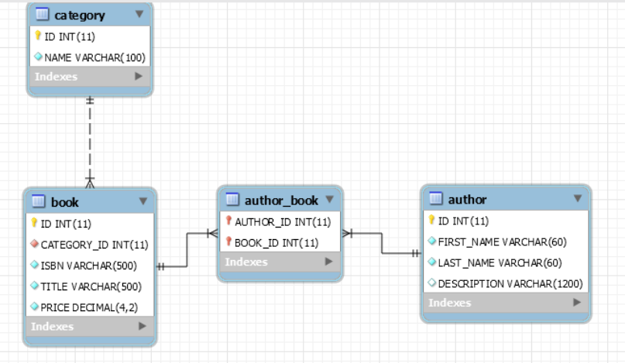

1. I used the Maven command line to create my project:

**mvn archetype:generate -DgroupId=edu.herve.spring.hibernate -SpringHibernate**

**-DarchetypeArtifactId=maven-archetype-quickstart -DinteractiveMode=false**

1. I edited the **pom.xml** and I added the necessaries dependencies.
2. I created the folder **main\resources** manually .
3. I created the folder **main\resources\META-INF\sql** where I put my **shema.sql** corresponding to my database shema and **test-data.sql** to insert some data; the data are

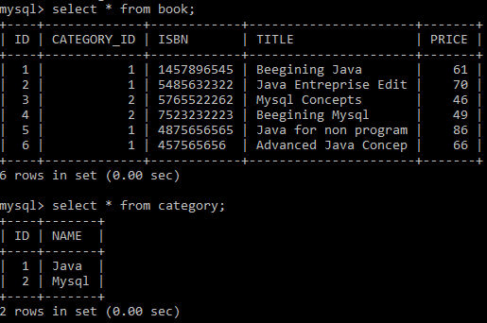

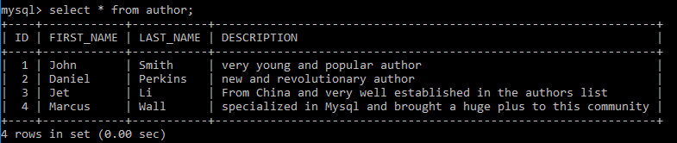

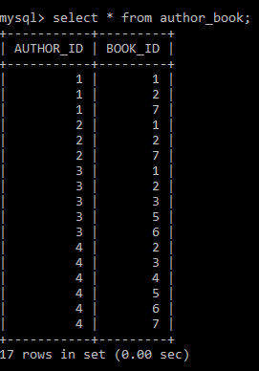

1. I created the folder **main\resources\META-INF\spring** where I put my **app-context-xml.xml**
2. I imported my project into Eclipse IDE and I created the packages:

* **edu.herve.spring.jdbc.domain** containing the classes **Book.java, Author.java** and **Category.java** corresponding to the tree tables book, author and category on the database.
* **edu.herve.spring.jdbc.dao** containing the interface **PublishingDao.java where i created the methods corresponding to the functionalities of my program.**  The class **PublishingDao DaoImpl.java** implementing the interface **PublishingDao Dao.java**.
* **edu.herve.spring.jdbc.app** Containing the classes executing each of the functionalities listed in the assignment.
* **AppFindAll.java :** find all books without authors and categories
* **AppFindAllWithDetails.java:** find all books with authors and categories.
* **AppFindByBookId.java:** find a book with authors and category by book's ID
* **AppfindByAuthorId.java:** Find all books for one author id who has more than one book in the database.
* **AppSaveNewBook.java:** add and save in your database a new book.
* **AppDeleteExistingBook.java:** delete the saved book from the database.

This is the image of the structure of my project in Eclipse

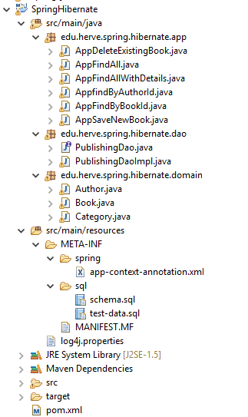

1. the building and the execution of my application has the following results.

* for the methods **findAll()**

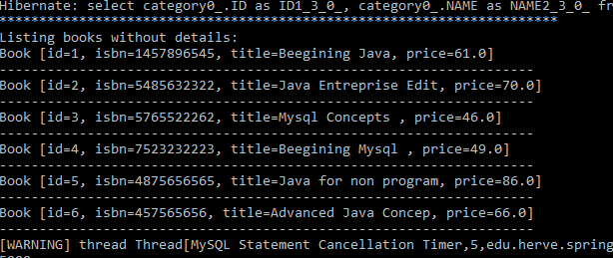

* for the method **findAllWithDetail()**

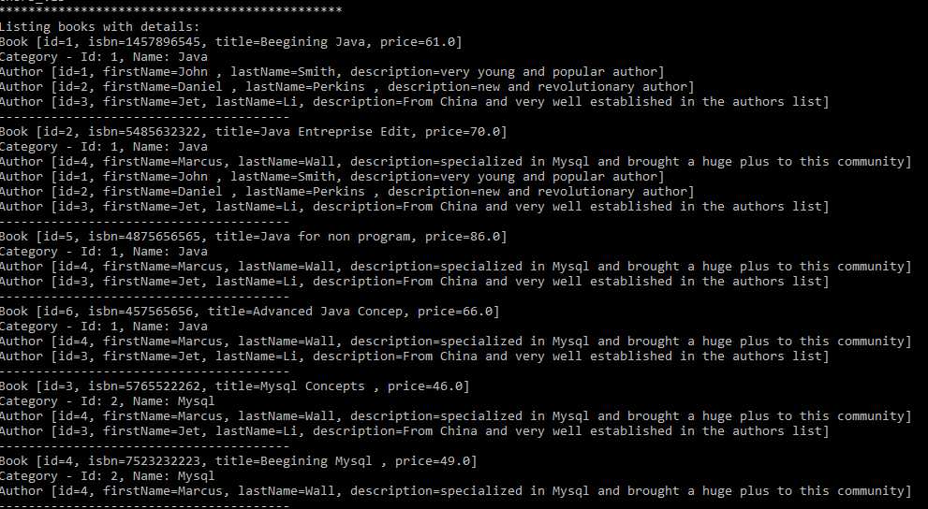

* For the method **findById(int id)**

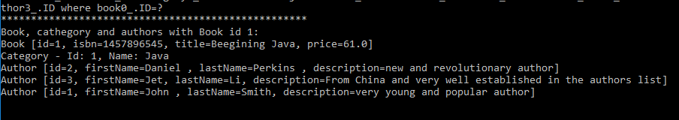

* For the method **save(Book newBook)**

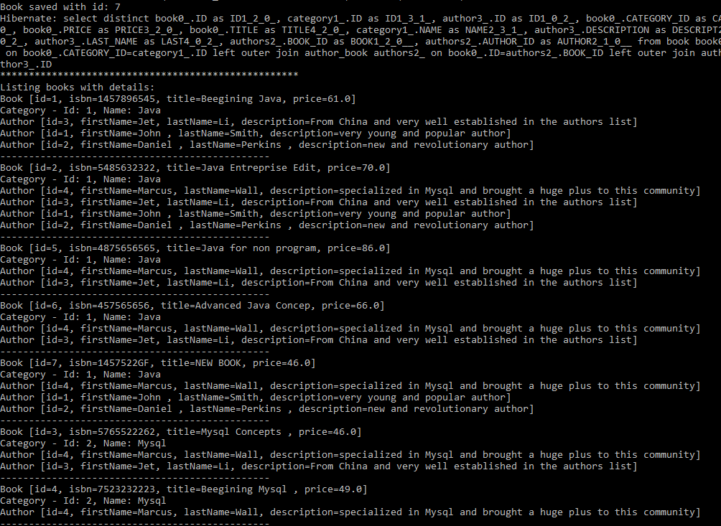

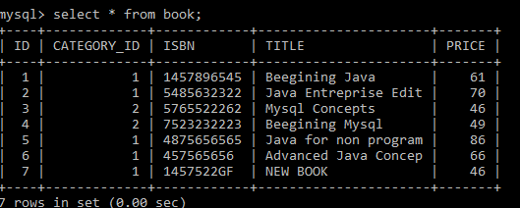

* For the method **delete(Book newBook)**

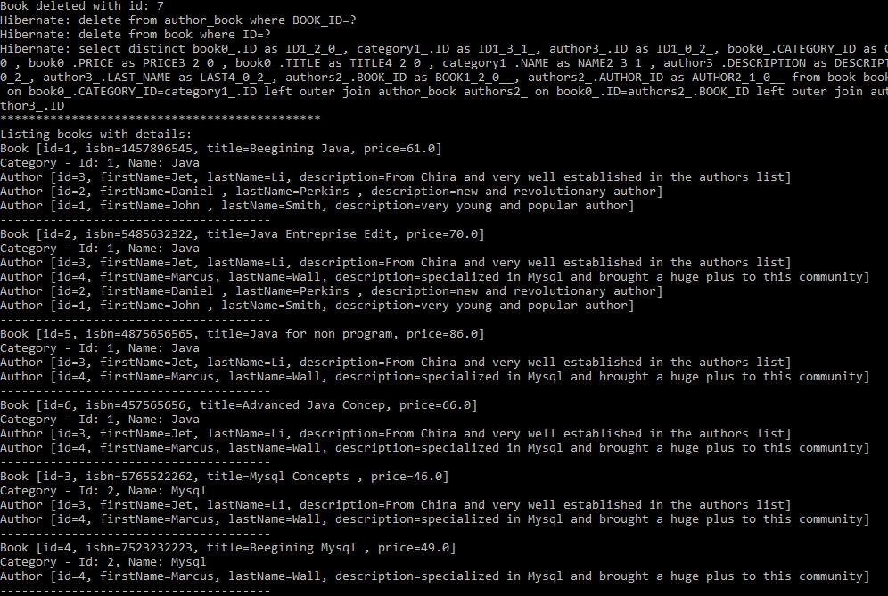

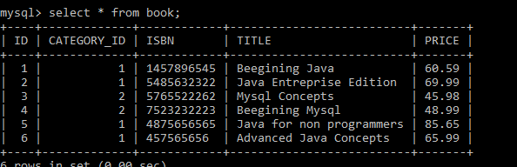

* For the method **findByAuthorId(int id)**

